* start as ball
* roll over sticks to pick up
* roll down hill and hit tree to get head
* 2 ball guy
* top ball turns into slush when too small
* things you can do with snow
  + throw it as a ball
    - snowball with face to make a new guy
  + interact with stuff to weigh it down
  + Shape

    Description automatically generated
* weight puzzles
  + seesaw
* size puzzles
  + roll through a log
* interactions
  + throw snow
    - Shape, arrow

      Description automatically generated
    - 4 directional throwing
    - up/down
      * ball grows then shrinks to show throw
      * A picture containing shape

        Description automatically generated
    - left/right
      * ball is in arc
  + shake off snow
  + make snow piles
* roll around as ball on top of hill to gain mass and face
* roll into brittle looking branch to break it into two sticks for arms
* camera pans out to show hill, roll down hill into tree to get snow to fall for second ball
* see house
* cutscene looking through window at sleeping family
  + thought bubbles for clothing items
* 3 puzzles to get 3 different clothes
  + scarf
    - A picture containing diagram

      Description automatically generated
    - throw ball with face to get past blockage
    - throw snowball to knock scarf
    - Shape, arrow

      Description automatically generated
    - scarf flies back to main area
  + hat
  + pipe
    - A picture containing text, bicycle

      Description automatically generated
    - be small to go through log, get big to knock down some snow to fill trench to get back
    - A picture containing text

      Description automatically generated
* final puzzle around house combining all elements
  + 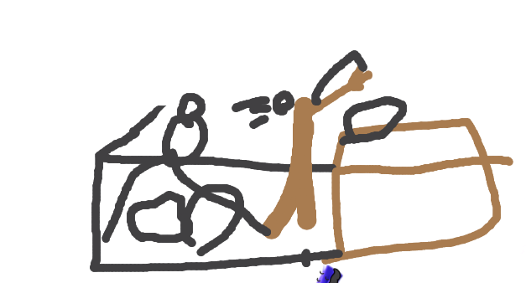
  + throw self through hole in fence, knock snow off tree by rolling into it, snow piles on roof
  + throw self from hill onto roof
  + 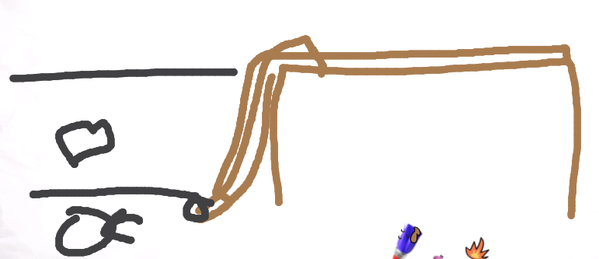
  + use gutter to get down
  + keys is on roof in a gutter
  + Shape

    Description automatically generated
* A picture containing text

  Description automatically generated

